UK Carbon Descent – leading the world down the carbon hill?
(David Calver, June 2013)

Introduction and context
In the wider context, the challenge (for all countries that choose to act on it) is to reduce global emissions of CO2 sufficiently by, say, 2050 in order to avert cataclysmic climate disaster.
The IEA has done some analysis showing one such global scenario, using a mixture of cleaner energy production and better energy efficiency (including demand reduction).
[IEA Energy Technology Perspectives 2010]
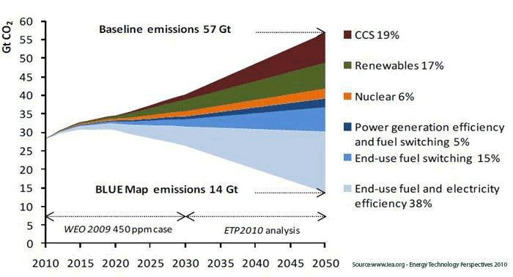
The UK’s future energy mix should be seen as an opportunity for this country to make its fair contribution towards this objective, which is generally seen as reducing carbon emissions from 1990 levels by 80% by 2050. The UK’s current primary energy mix is shown later in this paper.
Problems, barriers and policy issues:-
Consistent with the climate change ambition set out above, the UK Government has the following objectives for UK energy policy, ranked in priority order, to enable the UK to play its part in this massive decarbonisation of the world economy:
- Energy security (keeping the lights on – in the UK)
- Cost (keeping consumers’ bills down – in the UK)
- Environment (addressing climate change – or at least making our UK contribution to this shared global problem)
It is disappointing that environment comes at the bottom of this list. As a consequence of this, UK Government policy tends to favour a broadly spread mix of technologies, including CCS on fossil fuel energies, continuing existence of gas in the mix (including imports when necessary to plug energy gaps), wind and other renewables. Is this a cop-out, bending to lobbying from various vested industry sub-sectors, or a sensible and pragmatic stance given some of the limitations in the UK’s energy potential – eg the North Sea has passed “Peak Oil”, we have less sunshine than most countries, we are a very small island (so less scope for biomass, unless we import the fuel)? On the other hand, it recognizes the potential for wind energy, which draws on the UK’s geographical advantages regarding this resource. Solar energy appears to be merely a side-show in many UK scenarios.

Timeframe for completion
The UK DECC published a pathways 2050 tool in which scenarios can be tested for their impacts on emissions from all UK sources. This uses a timeframe in which more manageable transitions can be envisioned compared with the much more abrupt changes that would be required for a ten-year transition. For the UK, the timeframe to 2050 is a reasonable one to analyse because the UK population and demographic trends are not as dramatic as in many other countries. Shorter timeframes for transition might result in drastic, costly and risky energy transitions. In this paper, therefore, I shall use the timeframe to 2050 for transition.
For the UK, anyone can use an enhanced version of the 2050 pathways tool (based on the original DECC one) at the following website:
http://create.energynumbers.info/pathways/20111111111111110111111001111110111c11111011011011c111110110111/primary_energy_chart
You can select options for levels of various renewables etc. The Committee on Climate Change (“CCC”) suggests that one of the keys to succeeding in meeting the UK’s targets for carbon emissions is to focus on achieving carbon intensity of 50g CO2 per kWh generated in the energy sector by 2030. There are many possible combinations of energy sources that achieve this. Many of them don’t achieve it by 2030 but do achieve it by 2050. Few of the scenarios are totally free from fossil fuels. Most of them eliminate coal, but not oil or gas. Many include a significant proportion of wind energy. Rather than eliminating fossil fuels altogether, many of the published scenarios use CCS (Carbon Capture and Storage) as part of the mix.

Development of new renewable energy sources
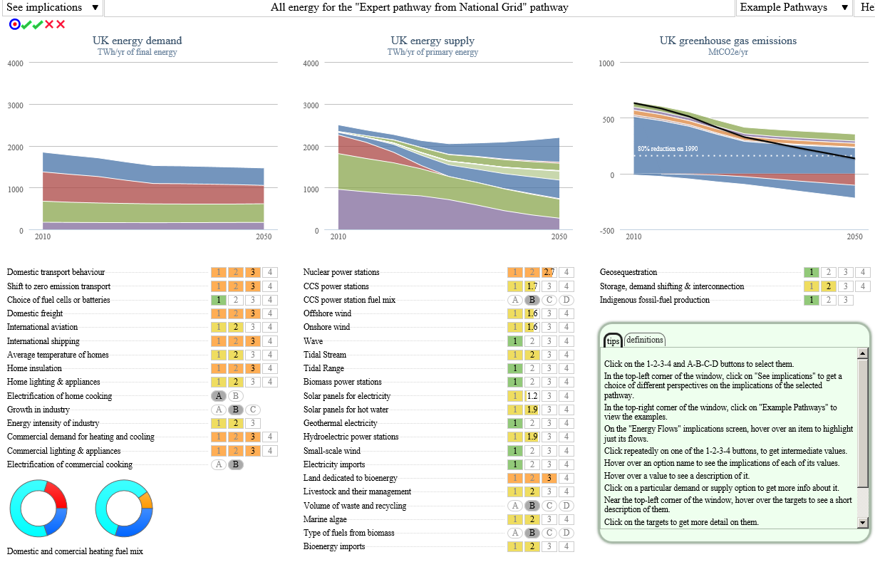
Below is one of the most pragmatic of the scenarios – created by National Grid from the Pathways 2050 tool. The current state of UK primary energy generation is shown at the left of the central diagram.
[UK pathways to 2050 tool - National Grid Scenario]

Diagram Colour Key (for central diagram – energy supply): - from bottom to top
Purple = natural gas
Light Green = oil
Brown = coal
Blue = bioenergy
Dark green = wind
Salmon pink = solar
Blue = nuclear fission

The diagram on the left of the picture above plots UK energy demand to 2050, the middle one plots energy generation and the one on the right plots GHG emissions.

The energy sources in this scenario pan out as follows (in TWh per year):
2010 2050
Natural gas 957 267
Oil 854 455
Coal 447 0
Bioenergy 60 445
Environmental heat 0 213
Wind 15 174
Solar 0 29
Nuclear fission 161 588
Total 2,494 2,171 TWh per year
This scenario phases out coal altogether, but retains some oil and gas (with significant CCS). All other renewables with scale potential are increased significantly, mostly wind and bioenergy.
The following is a scenario that is the same as the one above, except that it contains accelerated PV power – 95 TWh/year by 2025, 157 TWh/year by 2050:
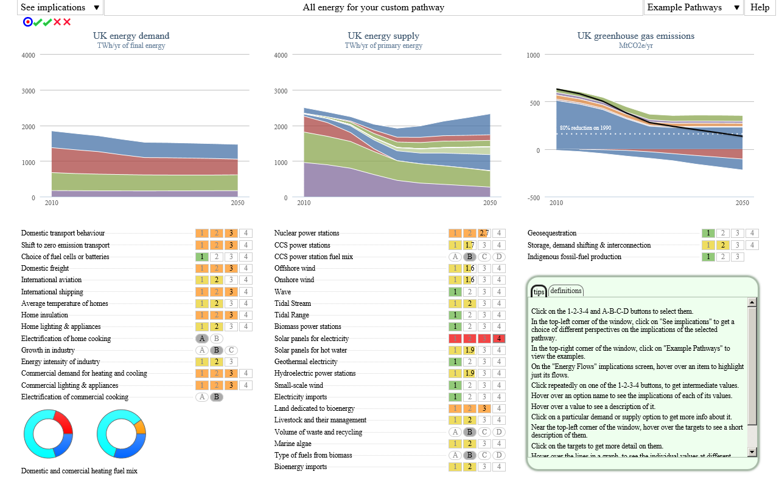
The power generation mix is as follows in this scenario:

2010 2050

Natural gas 957 267
Oil 854 455
Coal 447 0
Bioenergy 60 445
Environmental heat 0 213
Wind 15 174
Solar 0 157
Nuclear fission 161 588
Total 2,494 2,299 TWh per year

Another way of looking at the challenge is to target a particular level of carbon intensity of primary energy. This makes some sense, given that the main aim, from an environmental perspective, is to reduce carbon emissions. The CCC have done some useful work creating one scenario where the UK achieves a low carbon intensity of energy generation by 2030 – here is a diagram illustrating the breakdown of how the target is achieved. I think their scenario is not significantly different from the National Grid one above.
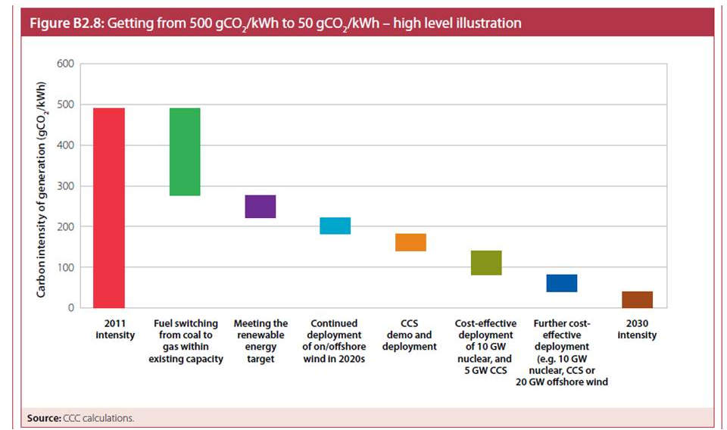
[ CCC-decarbonisation of energy]

Description of most promising (at scale) renewable energy source
Offshore wind is a big resource in the UK and will make a significant contribution to decarbonizing the UK energy sector. The following charts show the potential growth in capacity through to 2022 (as per the DECC Energy Trends report 2011).
[wind projections]

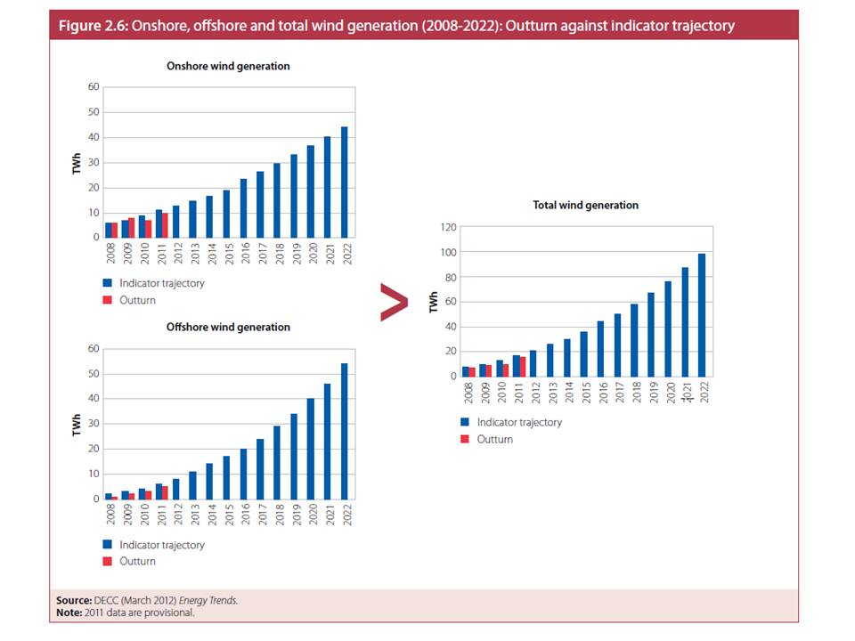

Summary
The UK, because of its context and available renewable energy resources and its priority to balance the triple objectives of energy security, cost-effectiveness and environment, is unlikely to be able to eliminate all fossil fuels by 2050. However, there are several scenarios under which it can eliminate coal, reduce oil and gas, maintain a level of nuclear for baseload, add CCS to remaining fossil fuels, add significant renewables (mostly wind), reduce energy demand and reduce the overall carbon intensity of primary energy to below 50g CO2 per kWh. The effect of each of these scenarios would be to achieve the ambition of reducing carbon emissions by 80% from 1990 levels.
The main issues are the potential trade-offs between the triple objectives, which could result in none of them being fully achieved, and sensitivities to underlying assumptions about modest but positive economic “recovery” or “return to growth”.
My main recommendation would be for Government to make more visible these underlying economic assumptions and to undertake sensitivity analysis on them. Changes in economic circumstances could provide an excellent opportunity to accelerate the rate of decarbonisation and/or to accelerate the reductions in fossil fuel energy within the mix.

